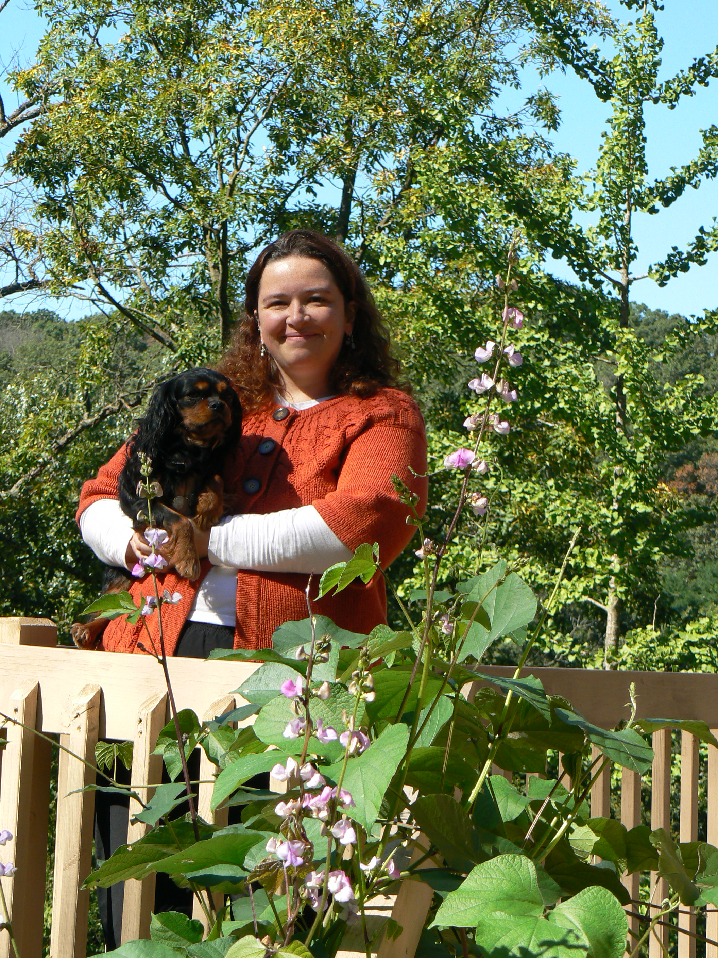 Christein Sertzel grew up in a dog and horse family with a childhood filled with pets and farm chores, and she learned at a young age to value kindness to animals and awe of nature. Chris also began to learn grooming while quite young age from a mentor and went on to learn proper handling and showing of her family’s Wire Fox Terriers and several other breeds as well as part of the AKC dog show circuit.
While still in school Christein took a walk in job at a grooming salon and was hooked. After several months at this high volume shop, she left to get formal training and certification working as an intern. After a year and losing her Grandmother, she took more time off to travel and follow the grooming competition circuit, fascinated with our industry icons and the newly developed GroomTeam. After two years of travel as well as doing some grooming study and one on one training overseas, she used the last of her inheritance to purchase her first grooming salon.
Over the years, she has worked in several of her own salons, vet clinics, and for free standing salons as well as corporate salons. All the while Chris gained knowledge and experience with a growing need to educate and network with other groomers in effort to be at the forefront of her career and to benefit the grooming industry in ways larger than herself. After another 20 years of grooming, training and growing her knowledge of all matters of grooming, it was time for a major change. Christein worked and received formal certification in first canine massage therapy, energy work and acupressure, and then in applied aromatherapy and flower essences. Christein spent a year of hands on training and apprenticeship under her Aunt, who practiced both canine massage and acupressure as well as animal energy work. Her next venture was a bed & biscuit that she ran herself and offered grooming and massage care as well as grooming training to interns.
After two years and a house fire, Christein moved and opened her spa in her current home where she also operates her canine massage and wellness center and breeds and shows Cavalier King Charles Spaniels under her kennel prefix Windyway.
At the same time Chris also started a non profit organization she named the Wisconsin Association of Professional Pet Stylists, Inc. to fill her need to work with and learn with other stylists, and to create a networking and educational medium larger than just herself. Christein strongly believes in working together for the betterment of our grooming and pet care industry and in continuing our grooming education on all levels whenever possible to award personal growth and work towards making grooming a profession instead of a vocation. In efforts to provide learning opportunities for all interested stylists, Christein often gives hands-on and one on one training seminars and mentors stylists as they climb the industry ladder. Chris also takes on students and seasoned stylists to train at her salon to get them started out right or to help them with applied breed grooming and techniques and certification. Christein developed an in-depth and challenging formal testing and certification program for stylists to achieve their Wisconsin State Certified Master Pet Stylist title, as well as many learning seminars throughout the year for WAPPS members. Along with other membership benefits for WAPPS members and fellow groomers, Chris holds an annual Pet Stylists Invitational- a day of learning classes and a two-tiered grooming competition as well as a Rescue Rover Makeover competition. Several months ago, Chris also finalized a member’s health insurance program for all WAPPS members and their families. This was a huge endeavor and celebrated accomplishment to get such coverage for self employed and employed members who could not afford reliable health insurance at their jobs or as head of household. Christein found this accomplishment hugely gratifying in that it got the needs of many of the WAPPS members and their families addressed and sent out a message that anything is possible if you keep trying.
Lately Christein is showing her Cavaliers, grooming and training in her salon, working as a product rep for Honest Kitchen dog foods, has created an entire line of excellent organic and all natural canine skin & coat care products for the grooming professional called “Canine Spa Therapies”, has written a wonderful book titled “The Competition Grooming Guidebook”- a complete guide for all stylists who are already competing or aspire to, and has currently been nominated for multiple categories 2 years in a row for the coveted Cardinal Crystal Award. Aside from her career developments in our grooming industry, Chris is loving and learning from her family including 3 small children, 11 dogs, an incredibly supportive husband, and working on a book for the industry titled, “Holistic and Encompassing Grooming”. This will be an encompassing book for all groomers to take knowledge from about total care and overall health of our pet clients from a groomer’s perspective.
After nearly 30 years in this industry, Chris takes great pride in trying to help others and giving equal respect to groomers on all levels in hopes of showing her peers that we should all work together and help one another in effort to move our entire industry along the upward trend that it has experienced over the past several years. She has learned so much from others and looks at her career as a vessel for personal growth and accomplishment, hoping that she will always be able to help and encourage others.

